GRADS+ Tool Descriptions/Protocol
The GRADS+ Case Management Model creates a formalized referral process for service collaboration and shared case management. The purpose of the model is to identify the needs of GRADS students and respond to those needs in a systematic way.
A series of tools was developed to support the case management model and formalize the referral process by:

- Identifying student needs (eSNQ)

- Directing students to referrals for care based on those needs and monitoring what services were or were not received (ALF)

- Gathering information on student satisfaction with the GRADS program and seeing if their needs are being met (GESS).

- Assessing the way in which teachers are implementing the GRADS+ Case Management Model to identify training and technical assistance needs (MSAT).

Table of Contents

GRADS+ Tool Descriptions/Protocol 1
eSNQ: Electronic Student Needs Questionnaire 3
Steps to administer the eSNQ 5
ALF: Agency Linkage Form 7
Steps to administer the ALF 8
GESS: GRADS Engagement and Satisfaction Survey 10
MSAT: Model Self-Assessment Tool 11

eSNQ: Electronic Student Needs Questionnaire

Why is it important?
Not only does the eSNQ provide prompt feedback to help direct and aid the individual student, but the eSNQ aggregates data about the program as a whole. Assessing student needs as a whole can help inform local program decisions by identifying high needs students and service gaps to develop strategies to address unmet areas of need. The student need data is also aggregated for the entire GRADS system, which can be used to identify service gaps and high need areas across the state and provide opportunities for problem-solving among state leaders.

What is it?
Completing multiple forms at a time may be helpful, like the eSNQ and the GRADS enrollment
The eSNQ is a tool for identifying student needs on a range of categories and providing immediate feedback to teachers and case managers about those needs. It is particularly useful for identifying critical needs. Once the eSNQ is completed via the iPad app and handed back to the teacher, the eSNQ instantly highlights key student needs in a snapshot report automatically created on the iPad, and alerts teachers to particularly critical needs (color-coded in yellow and red on the report).

When is it administered?
The eSNQ should be administered each semester within 30 days of student enrollment. Every GRADS student should therefore take the eSNQ twice each academic year: once in the fall and once in the spring.
If there is a high case load of students, it would be advised to divide the administering of the eSNQ between the teacher and case manager and even over a period of days. For sites with a fatherhood mentor, it is recommended that the fatherhood mentor also work to administer the eSNQ to young fathers.

How is it administered?
The eSNQ takes approximately 5-10 minutes for a student to complete. It is recommended that you go through the questions with students first to ensure that they understand each question. Using the iPad app, the eSNQ can be done one-on-one with a teacher, case manager, or fatherhood mentor. Once completed, the eSNQ delivers a color-coded report that identifies all student needs, with critical needs are highlighted in yellow or red. It is crucial that the report is viewed within 24 hours in order to give students the referrals for services they require.
Save a tree, use the iPad app!
We’ve moved forward; there’s no turning back!
Each site should develop a routine reporting process to decide:
1) who will administer the eSNQ (teacher, case manager, or fatherhood mentor)
2) who will view the report
3) who will meet with the student individually to issue referrals for services
4) who will document the referrals in the Agency Linkage Form (ALF) on the GRADS database

Steps to administer the eSNQ

http://vimeo.com/101334328
- Watch the video link above to see the eSNQ in action
- Try out the eSNQ yourself, using “Test, Test” for first and last names
- Review the questions with students so they understand the kinds of questions they will see on the eSNQ
- Student completes the eSNQ on the iPad
The eSNQ can be administered with an individual student by the teacher, case manager, or fatherhood mentor depending on the routine reporting process your site has in place. It can also be administered using multiple iPads in a group setting, as long as only one student uses the iPad at a time to maintain privacy. However, the group should be a manageable size (5-10 students) so all reports can be reviewed within 24 hours to spot students with high-risk needs. If using multiple iPads at a time, it is recommended to administer the eSNQ to only 5 students per session over the course of a couple weeks to make sure there is sufficient time to view reports and refer students with high-risk needs.
- Review the color-coded summary of needs within 24 hours
After the student completes the eSNQ, a color-coded summary of needs can be emailed as a secure .pdf or printed out. It is important to meet with the student individually to review the identified needs according to the timelines specified below:
RED | need is high risk and requires attention within 24-48 hours
YELLOW | need is medium risk and requires attention within 1-2 weeks
BLUE | a question was not answered
WHITE | there were no issues reported
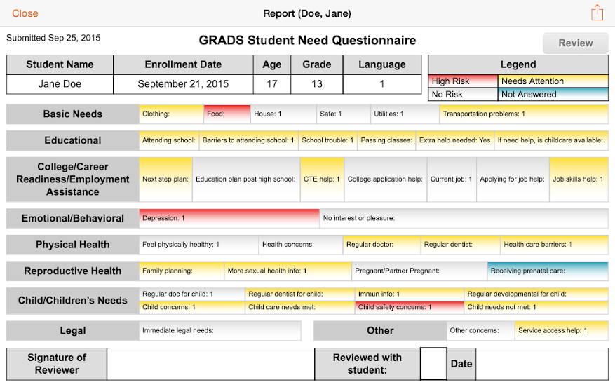

Using the printout will help guide your work, both one-on-one with students and in lesson planning
- Meet with the student individually (within the appropriate timeframe) to review the summary of needs
Meeting with the student one-on-one provides an ideal opportunity to connect and build rapport (see the tip sheet on establishing rapport), and engage the student in a discussion about the needs that they identified.
- Provide the student with referrals that address their needs
For example, if the student states that they are having feelings of anxiety or sadness, offer a referral for counseling services that are available at the school and/or in the community. It is important to have a current directory with available community resources and services.
- Enter the referrals in the Agency Linkage Form on the GRADS database
After entering the referral, print out the referral form for the student. Ask the student to follow up on the referral status for each referral by documenting whether they received the service or not. This is a good opportunity to discuss self-advocacy with students.

ALF: Agency Linkage Form

Why is it important?
The ALF offers a consistent way to address student needs by providing referrals and follow-up to ensure that services were received by the student. The ALF is aggregated at the local and state level and can show the type of referrals that students need the most. Additionally, the ALF provides critical information for required federal performance measures, closely tied to the grant funding.

What is it?
The ALF provides information on the frequency and types of services to which GRADS students are referred, and whether or not students actually received the services. The ALF is a part of the GRADS database and collects information about where students were referred (based on the needs assessed in the eSNQ), and if they received these services. Referrals should only include services OUTSIDE of the GRADS program.

When is it administered?
Begin entering referral data for each student on the ALF in the fall semester, preferably after the administration of the eSNQs. Continue to enter timely referral data on the ALF so that it is fully updated by the end of the year.

How is it administered?
For each student need identified in the eSNQ (and any other needs identified by the teacher, case manager, or student), enter a referral for services in the Agency Linkage Form that can be found in the GRADS database. Print out the referral report and hand it to the student. The student will use this report to record if and when they received a particular service. At the end of the semester, these reports should be collected from the student and entered into the GRADS database.
Food for thought: linking the ALF into a classroom lesson or activity both helps you and helps empower the student

Steps to administer the ALF

- Meet with the student to discuss which of their needs can be addressed with a referral
A good rule of thumb for what constitutes a referral is: referring a student to any one-on-one, additional services (outside of general classroom time) spent with a student to direct them to specific services. For example, a group presentation on Teen Dating Violence would not constitute a referred service for every student in attendance. However, if a student stayed after to consult with and get advice from the presenter, that would constitute a referral.
- Enter a referral for each identified need in the ALF on the GRADS database
Insert the date of the referral, type of referral (e.g., basic needs, etc.), the specific needs (e.g., clothing, food, etc.), and the provider who will be providing the service.
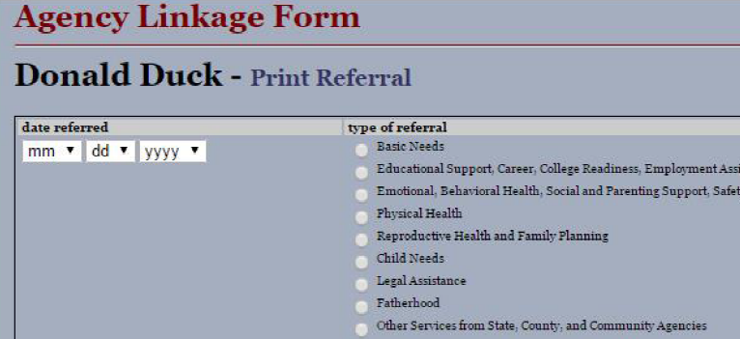

- Print out a referral report for the student
The referral report will list the date the referrals were provided, the needs identified, and the providers. The student will use this report to record if they received that particular service and the date it was received. When possible, provide the student with a “warm hand-off” to the provider. For example, if the referral is for the SBHC, walk the student over to the SBHC and introduce them to the staff.
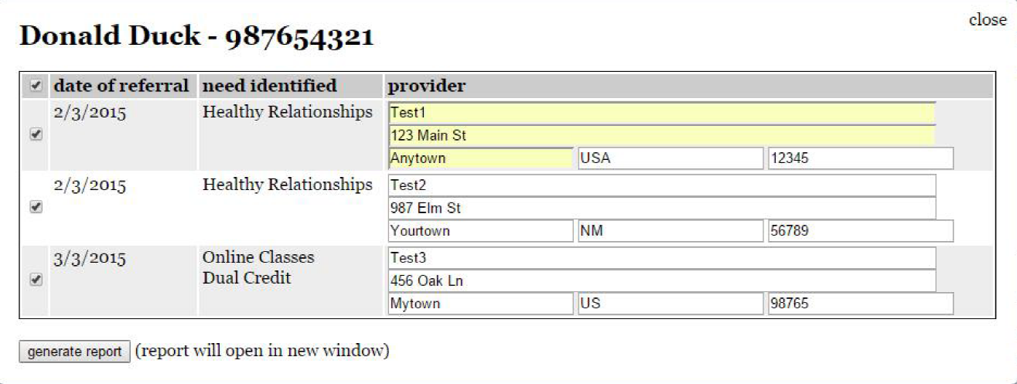

Hit “generate report” and a report will appear in a new window for you to print:
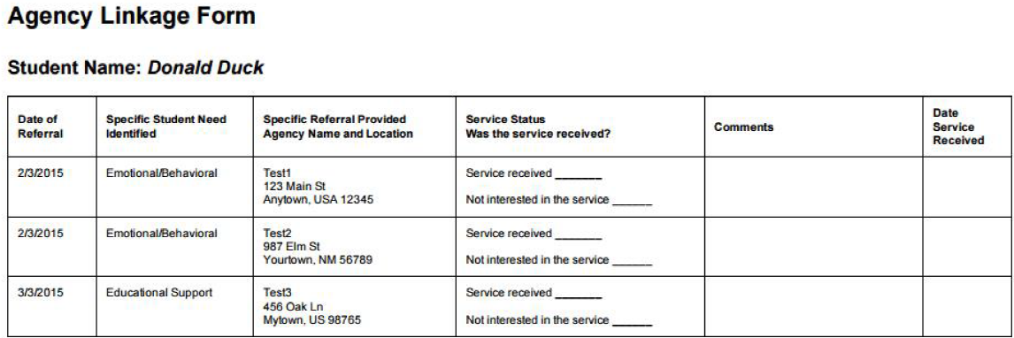

- Collect student referral reports at the end of the semester and enter the status for each referral in the GRADS database
Documenting whether or not services were received is an important step in the referral process and is reported in the federal performance measures. Having students provide follow-up on their own referrals also helps encourage self-efficiency and health advocacy for themselves and their children. Consider using this student activity as part of a lesson on health literacy and advocacy. However, a student’s choice to not disclose service status should be respected.

GESS: GRADS Engagement and Satisfaction Survey

Why is it important?
The GESS is part of a student-centered approach that encourages students to be meaningfully engaged in all aspects of the GRADS program. It gives students a voice by providing an ideal opportunity for them to give feedback on the services they receive, how the program benefits them, and how it can be improved. The survey is an important part of the quality improvement process and results can be used to make program changes and improvements where needed. GRADS sites can also share the survey results with their advisory committees, school administration, and school board to show how their GRADS program is making a difference in the lives of young parents.

What is it?
The GESS is an iPad-based satisfaction survey developed to give GRADS students the opportunity to provide feedback on the services they received through the program.

When is it administered?
The survey is administered at the end of the school year. Depending on classroom size, administration of these surveys could begin as early as March and be completed over a period of a few weeks.
Serving your students is our goal! They know what they need best, and this is how they can communicate that to us!

How is it administered?
The GESS is an anonymous survey and takes approximately 10-15 minutes to complete. Students use the iPad app to complete the survey. Survey results are then provided to each GRADS program.

“It has made me more aware of how to be a better mom. Also, that lots of people go through the same thing as me and I can do it. I’ve learned that I can go to someone if I’m feeling overwhelmed with something so that they can help.”
-- GRADS student

MSAT: Model Self-Assessment Tool

Why is it important?
The GRADS+ Model is a primary focus of the Support for Expectant and Parenting grant from Health and Human Services, Office of Adolescent Health. The model was developed to evaluate and respond to the needs of GRADS students to achieve positive educational, social, and health outcomes of expectant and parenting teens and their children. The model is designed to coordinate available school and community services to provide needed resources and services that support educational and parenting success. The MSAT gives a site and overall view of the how the GRADS+ model components are being implemented.

What is it?
The MSAT is an online assessment tool that documents details about the level of site implementation of the GRADS+ model, which includes enhanced case management, supporting young fathers, college and career readiness, and early childhood and infant mental health. Each component consists of quality indicators that are used to measure the implementation of that specific component. Sites are guided through a series of questions for each of these quality indicators to assess how they are being implemented at the site level. For each quality indicator, teachers are asked if the indicator is currently practiced, to provide a description of how the indicator is practiced, whether there is need for improvement and specific plans for improvement.
The MSAT informs GRADS programs about the level at which they are implementing the GRADS+ model on the following components:
- Student-Centered Approach
Don’t be shy! The MSAT is a great place to showcase all you’ve implemented and achieved over the past year
- School and Community Outreach
- Intake, Assessment, and Service Place
- School and Community Resource Team
- Continuum of Services
- Enhancing School Support and Services
- Increase Access to School-Based Health Center Services
- Increasing Access to Government and Community-Based Services
- Formalized Referral Process
- Service Coordination
- Staff Training and Professional Development
- Continuous Quality Improvement
- Supporting Young Fathers
- College and Career Readiness
- Early Childhood and Infant Mental Health
Please refer to the manual for detailed description of each of the components in this survey.

When is it administered?
The survey will be available at the end of the school year.

How is it administered?
If you did the MSAT last year, you don’t have to re-enter everything again. All you have to do is update it!

Teachers will be sent a link on FluidSurveys to fill out the survey and receive a gift certificate upon completion. Teachers who have already completed the MSAT will only have to enter an update each year.

Before you hit “submit” you can save your survey as a .pdf and print it. You can use this printed report to showcase and document your GRADS program. The report can also serve as a work-plan for any improvements you may want to make in your program.
Additionally, the report will be distributed in the GRADS site Snapshots.

Because the survey asks you to assess your GRADS program related to the implementation of the GRADS+ model components, it is important that you review your program with a critical eye and are completely honest regarding what is actually occurring. This isn’t an audit; the results help inform the GRADS program about how teachers are implementing the model and in what ways they can support teachers in enhancing their programs.

